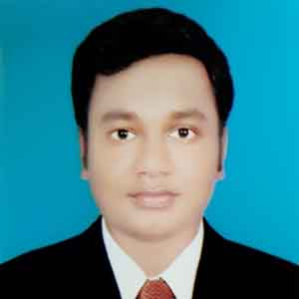***CURRICLUM VITAE***

***OF***

**MD. SHAMIM REZA**

**Mobile: 01734-902564**

**E-mail : shamim.reza31@yahoo.com**

**Career Objective:**

Willing to work in a position where I will get the Opportunity to work in a team or individually and get chances to increase my skills, efficiency, capacity and leadership quality which ensure my future career development.

**Academic Profile**

**Master’s of Social Science( M.S.S)**

Name of Institution : Govt. Ananda Mohan College, Mymensingh.

Subject : Economics

Result : 2nd Class

Passing Year : 2013

University : National University

**Bachelor of Social Science (B.S.S)**

Name of Institution : Govt. Saadat College, Tangail.

Subject : Economics

Result : 1st Class

Passing Year : 2012

University : National University

**Higher Secondary School Certificate (H.S.C)**

Name of Institution : Susang College, Durgapur, Netrakona.

Subject : Humanities

Passing Year : 2008

Result : 3.90

Board : Dhaka

**Secondary School Certificate (S.S.C)**

Name of Institution : Barodal High School, Kalmakanda, Netrakona.

Subject : Science

Passing Year : 2006

Result : 2.13

Board : Dhaka

**LANGUAGE PROFICIENCY**

* Bangla- Excellent speaking and writing ability.
* English- Excellent speaking and writing ability.

**COMPTER SKILL**

* MS Word, MS Excel, MS Access, MS PowerPoint & Internet Browsing etc.
* Database Programming for 06(six) months Training Completed under “ NTC”,Tangail.

**EXTRA CURRICULUM:**

* Ability to work efficiently in a team environment.
* Ability to work under pressure.
* Good Organizing skills supported by excellent communication capabilities

**Personal Information:**

Name : **Md. Shamim Reza**

Father’s Name : Md. Abdur Rouf

Mother’s Name : Minara Khatun

Present Address : Vill: Kantopur, P.O : Barodal, P.S: Kalmakanda,

Dist: Netrakona.

Permanent Address : Vill: Kantopur, P.O : Barodal, P.S: Kalmakanda,

Dist: Netrakona.

Date of Birth : 25th September, 1989

Nationality : Bangladeshi

Religion : Islam

Gender : Male

Blood Group : O(+ve)

Height : 5 Feet 7 Inch.

Weight : 70kg

Home District : Netrakona

**Experience** : i) Name Of Organization : Palli Mongal Karmosuchi

Designation : Credit Officer

Area : Boirab

Experience Length : 17 November 2018 to till Now.

I hereby, declare myself that all statement in this Curriculum Vitae are authentic complete and to the best of my knowledge and belief.

**Md. Shamim Reza**

Date:.......................